**PACIFIC STATES UNIVERSITY**

**Business Plan for a Start Up Company: Delicious, Incorporated.**

**IS530 – Advanced e-Commerce**

**September 2013**

**Professor: Sam Ryu**

**Prepared by:**

**Anastasia Tiffany Valens**

**Table of Contents**

Executive Summary……………………………………………………………………………..1

Company Overview……………………………………………………………………….…….2

Vision………………………………………………………………………………..…..3

Mission…………………………………………………………………………………..3

Objectives…………………………………………………………………………….....3

Values…………………………………………………………………………………...3

Products and Services…………………………………………………………...………………4

Business Model…………………………………………………………………………………5

Business Category………………………………………………………………………5

Revenue Model ………………………………………………………………………...8

SWOT Analysis…………………………………………………………………………...…...10

Marketing Strategy………………………………………………………………………….…11

Situational Analysis……………………………………………………………………11

Our offerings……………………………………………………………………..……12

Market Segmentation…………………………………………………………….……14

Advertisement Strategy……………………………………………………….…….…15

Operation Strategy………………………………………………………………………….…15

Operations Model……………………………………………………………..…….…15

Technology behind Delicious.com………………………………………………………….......16

Management Structure……………………………………………………………………...…20

Financial Consideration…………………………………………………………………….…21

**Executive Summary**

E-commerce market continues to grow and e-commerce shows no sign of stopping as the amount of online purchases has increased even during the economic crisis in 2009 – 2011. According to Forrester research, e-commerce will continue to gain more market share. Forrester states that, "When we asked where customers would shift their retail dollars, the channels with the greatest shifts were the mass merchants, warehouse, and Web retailers."

According to Forrester research, US online retail reached $175 billion in 2007 and is projected to grow to $335 billion by 2012. Every year, business-to-consumer (B2C) e-commerce maintains its double-digit growth rate, in part because sales are shifting away from stores and in part because online shoppers are less affected to unfavorable economic conditions than the average US consumer. Despite the continued growth of the channel, online retailers face several challenges: Online merchants are broadly perceived as a second choice for shoppers, online retail is becoming increasingly seasonal, and online shoppers rarely admit to browsing, which can drive valuable incremental dollars during their Web shopping experiences.

Delicious is a start-up company focusing on online eatery business. It plans to connect millions of customers of with restaurants, cafes, caterings, and food vendors. Delicious is available 24 x 7 to the internet friendly customers. It is a virtual online market place facilitating easy buying and selling of appetizing cuisines. Delicious aims to tap the growing American consumer food market. Delicious plans to start with its presence in seven major cities in United States namely Los Angeles, San Francisco, New York, Boston, Seattle, Houston & Chicago, and then increase its regional base to more cities in North America.

Delicious plans to be the leading destination for online procurement of cuisines from eateries that exist in the US. The Internet has provided the means to fulfill customers’ orders without having to go to the physical stores to buy products or services. Operating from cyberspace, Delicious.com connects users with local vendors through B2C engagement, and supports small business owners as brick and mortar stores are not needed to perform e-business. Our mission is to provide users with fast, reliable, convenient delivery without ever having to leave their places.

For customers, Delicious will transform their food ordering experience. Our users can skip the long lines at the eateries and forego trips to the vendors. Our website allows users to order food at any time preferred, with just a few clicks at their computers. Delicious is dedicated to online food ordering business. It allows users to easily explore a variety of choices of local and regional cuisines in the U.S. to appetizing and exotic culinary dishes sold by vendors with backgrounds from all around the world. Food enthusiasts would be taken care of their cravings through this food portal. Our delivery system is fast, reliable, and accurate in respect to the addresses the users put in the request.

As a common platform where participated restaurants, cafes, caterings, and food vendors, can supply the needs of the household customers, Delicious enables an elaborate market reach to the business owners and provides convenience to the customers. Our online platform facilitates users to choose from a wide variety of items listed by the eateries. It also allows the eateries to enlist their products and ramp up their sales by increasing their reach. This portal acts intermediately between our eateries (restaurants, cafes, caterings, food trucks, and vendors) and the customers, nurtures and grows the customer base of these eateries by giving recommendations, top picks, favorite eateries based on past purchases. It also uses social media integration, easy search engine features that would be useful for customers to find available local eateries according to their budget, taste, likes, and preferences.

**Company Overview**

Delicious is focused on online eatery business. Available 24 x 7 to the internet friendly customers, it is a virtual online market place facilitating easy selling and buying of appetizing cuisines. Delicious aims to tap the growing American consumer food market. Delicious plans to start with its presence in seven major cities in United States namely Los Angeles, San Francisco, New York, Boston, Seattle, Houston & Chicago, and then increase its regional base to more cities in North America.

**Vision**

Delicious is a web start up that aims to make online procurement of delicious cuisines available only with a few clicks all over North America. Its visions are:

* To act as a platform for business owners for setting up and maintaining online eateries.
* To be the largest multiple merchant venue of eateries in USA.

**Mission**

Our mission is to provide an online platform where people can shop from various participated eateries: restaurants, food caterers, cafes, and food vendors. Delicious answers the needs of efficiency, quick, reliable, convenient services. It would allow customers save time, efforts, energy by increasing ease in accessibility and serving customers who do not find traditional ordering process at the brick and mortar eateries viable due to many unavoidable reasons. Our foremost mission is to provide convenience to the customers followed by best value for money backed by quality and satisfaction.

**Objectives**

The main objectives of Delicious are as follows:

* To serve our customers flawlessly.
* To build a stable, effective network between various eateries and buyers.
* To bridge the gap between the seller and the customer.
* To provide an online platform for small business owners so that they could gain a competitive edge in the restaurant business since the overall costs of store maintenance are relatively low.
* To facilitate users in browsing food from various eateries.
* To provide the best food ordering system on the web.
* To give our customers the best value for money and quickest service.

**Values**

We aim to build our business along the path of great values and business ethics which includes:

* Integrity
* Quality
* Excellent
* Leading Change
* Respect for Individual
* Learning
* Sharing

**Products & Services**

Delicious is an online e-commerce portal interlinks food enthusiasts with various eateries in their cities. Searching to a restaurant or seeing the categories, it lists all the eateries available sorted according to users preferences: distance, relevance, average menu price, delivery time, and many more. It enables restaurant entrepreneurs to market themselves and have a wide range of customers while it enables house hold customers to enjoy the food in their comfort of their own place, e.g. homes, workplaces, offices, schools, universities, colleges, hotel rooms, and so on.

Delicious gives on the spot delivery and reaches the doorstep of customers, while also provides a 24-hour customer service that would notify the customers when their orders are ready to be delivered and on the way to their addresses. Ordering online has some benefits: customers can customize their orders according to preferences, add notes, view the complete menu with pictures and details information, pay with various online payment methods, avoid waiting time in the eateries. Customers can also chat online or speak directly to the customer service to assist them with their orders. It is perfect for anyone in the need of delicious food who may not want to leave his or her place. Depending on the eateries, Delicious also has the option of picking up orders at certain locations as "to go" order.

Sellers can log in online to see the lists of orders, edit their menu, view most sold items of the menu, create discounts, promotions, coupons, and also request help from our team to manage orders or contact customers about their orders.

**Business Model**

Delicious is a common platform where business owners set up and maintain online eateries while also cater to the needs of online customers of easy, reliable, fast online fulfillment of delicious food from various eateries in their cities. Delicious enables a greater market reach to the business owners and convenience to the customers.

It provides an e-commerce platform for customers to choose from a wide variety of food listed by the eateries. It also allows the business owners to ramp up their sales by increasing their reach of potential customers. This portal acts intermediately between our eateries (restaurants, cafes, caterings, food vendors) and the customers, while also nurturing and growing the customer base of these eateries as it provides customers with a lot of helpful features which include recommendations, top picks, favorite eateries based on past purchases, social media integration, easy search engine for customers to find eateries available locally according to their budget, likes, and locations.

**Business Category**

The main model of business based on customer segment and the type of their interaction with the suppliers that we use is:

**Business to Customers (B2C):** E-commerce model in which business transactions conducted between a company and consumers who are the end-users of its products and services.

This is meant for online customers. This model is built around providingconvenience, quality and best value for money to the end users. The customers canbrowse through the menu and see the different items listed by the shops. Thecustomer orders the selected items on the menu and we deliver the product to their locations. This is our main focus and we concentrate all of our initial resources at this.

**Business Process**

The business process for Delicious is very simple. The Process can be segregated into the following sub categories:

1. Buying Process

2. Selling Process

**Buying Process**

**Registration**

To buy on Delicious's website one must be a registered user. It is fast, easy and free. As a registered user, they can shop and place orders on Delicious.com. The registration involves the following steps:

1. Contact Information

2. User ID & Password Creation

3. Email Confirmation

**Browse**

Browsing is navigating through our website, typing what customers are looking for known as the "keywords" into the search box, and also clicking through lists of titles called categories until one find something they are interested in.

**Select**

Users can add the items they are interested in to the shopping cart. Before placing an order, they can learn about the seller and the items on the menu. To make an informed decision, the users are expected to pay attention to the:

* Listing information
* Details and descriptions of the item
* Delivery and payment details
* Seller information

**Payment**

After the users select the items, they are presented with a choice of payment modes/methods. There are many payment methods and most sellers offer more than one. Some methods offer more protection than others.

Listed below are the most common payment methods:

* Cash on Delivery.
* Credit Card.
* ATM/ Debit Card.
* Online Gift Certificate.
* PayPal.
* Bill Me Later.
* Buyer Pays and Picks Up.

**Feedback**

Feedback is made up of comments and ratings left by users who have bought from and thank you notes or comments posted by sellers to the users. Once you have received your item, it is time to leave feedback for the seller and the item, letting future buyers know about your experience with the seller or impression for the site and services.

Type of information typically included in seller feedback:

* Satisfaction with the food
* Quality of communication
* Quality of presentation of the food
* Speed of delivery
* Courteousness

**Selling Process**

This allows the eateries to enlist themselves and items they sell to reach to the customers.

**Seller Registration**

The seller must enlist themselves by registering themselves with a fixed cost amount. The registration involves the following steps:

1. Contact Information

2. User ID & Password Creation

3. Email Confirmation

**Enlist Items**

The seller must enlist their items to the menu with appropriate details, pictures, description, prices etc. Each item enlistment requires a one-time cost.

**Manage Items**

The sellers are allowed to modify their entries, which are already listed.

**Feedbacks & Remarks**

Feedbacks from the sellers are taken to improve the process.

**Revenue Model**

The revenue model of our website is very simple. Delicious.com gives free browsing for any customer. The revenue model is presented in the following sub categories, namely:

**1. Registration Fee**

Sellers pay annual rent for registering to Delicious.com. In order to enlist their products or to put any kind of advertisements the companies must be registered. This is a fixed rent, pro-rated per month to help seasonal small vendors and it is determined according to the company size of the eatery.

* Business with 1-3 employees: The annual rent fee is $30.
* Business with 4-6 employees: The annual rent fee is $120.
* Business with 7-9 employees: The annual rent fee is $200.
* Business with 10-15 employees. The annual rent fee is $300.
* Business with 15-20 employees. The annual rent fee is $400.
* Business with more than 20 employees. The annual rent fee is $500.

**2. Listing Fee**

Seller also pays a very small one-time fee for listing each product. This is a variable rent weighing the cost and various other factors in mind.

**3. Commission Charges**

Commission Charges are stated four percent of the price of items sold excluding the tax and the delivery fees which are managed by the sellers.

**4. Advertisements**

Delicious.com allows different advertisements from outside companies to display postings and banner ads on its website. This is projected to be our main source of revenue.

**5. Lending Our Personnel**

We also rent our delivery service personnel to restaurants with relatively quite low fees, as about $8 per hour. This generates some revenues which would be used to compensate the wages of our delivery men.

Overall revenue sources are presented in the following chart:

**SWOT ANALYSIS**

**Strength**

* **Robust Technology**
* **Experienced and Expert Team**
* **High Market Demand**
* **Strategic Innovation**
* **Extensive Choices in One Place**

**Opportunity**

* **Local Reach**
* **Nationwide network**
* **Social and media integration**
* **Mobile Application**

**Weakness**

* **New Concept**
* **Disruptive Technology**
* **Relies on Internet**
* **Appeals to Certain Demographics**

**Threat**

* **New Entrants**
* **Competition from Stand Alone Online Eateries**
* **Brick & Mortar players**

**Marketing Strategy**

Delicious targets a niche category of customers with specific needs. It would build awareness across the population for converting the needs to demands. Departing from stimulating e-commerce market in the U.S., Delicious.com is a great instrument designed to replace the traditional practices. The marketing strategy will be in tune with the vision and mission to reach our objectives.

**Situational Analysis**

The traditional practice of purchasing food from the eatery is characterized by:

1. Manual process: looking for the eatery, finding its whereabouts, going there, waiting to be served, placing an order, until receiving it.

2. Time Consuming

3. Location constrained

4. Inconvenient

Delicious.com delivery services can be as much as 20% cheaper than the costs of customers visiting the eateries using their cars which occasionally involve parking fees, or the costs of using public transportations, and the time spent. Sometimes waiting in the busy restaurants to begin ordering food is very time consuming, with our ordering system, customers can start begin looking at the menu and find out what they would like to order at anytime, 24/7. Unlike other online ordering systems, we collaborate with the eateries to ensure the availability of items on the menu for online orders is secured, as the stocks of food, resources, and preparations for online orders are separated from their brick & mortar operations. The items on the menu have already been estimated and prepared to meet the demands of online order. Some of our eateries are specialized in "to go order" fulfillments. These businesses have facilities to cook and prepare the food to their best but may not have the option of dining in at their shops, or space is limited to dine in on the spot. Namely our eateries also include delicious caterings, bakeries, food trucks, seasonal food fair vendors, and many more, which now could expand their businesses and net more customers by engaging in e-commerce through our platform.

**Matching to Customer Needs**

We have identified the following points in the industry that our customers can benefit.

**1. Convenience**

In this fast paced life of metros, at times the customer does not have time to reach, walk, take public transportations, or drive down to the eateries and buy food. The drive takes petrol and time, occasionally with traffic frustrations. Customers need convenience of on the spot delivery to their locations. On other situations, customers may want to have their food delivered to their places because other circumstances cause them to unable to leave their places.

**2. Easy Assistance of Ordering**

We provide customers with 24/7 caring and attentive customer service. To place an order, customers only need access to the internet and navigate to the menu and its items. If preferred, Delicious.com also gives an option to direct calling, both from the customers phone and the button of Internet calling, to our customer service team who will assist customers to place an order to the eateries. We guarantee on-the-phone-waiting-time to reach the customer services does not exceed 5 minutes. For fastest option, Delicious.com encourages online ordering which is very easy to do, and simple, as customers just need to click to add the items they want into the shopping cart, fill in delivery and payment information, and complete the payment process, and the food would be prepared to your needs and delivered in short time.

**3. Value for Money**

Delicious.com urges, motivates, and assists eateries to provide discounts, coupons, points, promotion, and all deals to the customers. It promotes a great value for money for all its offerings.

**Our Offerings**

Our offerings are very simple. The offerings can be categorized into the following categories:

**Offerings to Sellers**

Our offerings to the eateries are very lucrative at a minimal cost.

1. Greater Reach

2. Greater sales volume

3. Easy access

4. Internet presence and advertising

**Offerings to Customers**

Our offerings to the customers are:

1. Convenience: we help customers to experience a quick, reliable and convenient process.

2. Quick delivery: the food would still be hot at the delivery.

3. Comprehensive details of the item: along with the very clear pictures and the descriptions of the food. Some eateries provide calories and nutrition facts to assist customers with special needs.

4. Quality Assurance: to ensure quality, we provide routine checking of the eateries and also include feedbacks of customers on the site that could help preserving the quality up to the par.

5. Value for money: Delicious.com produces and distributes coupons and various deals from eateries.

We can get the best interest of the market. As complicated market opportunity analysis is, competitors are plenty in the market and even some technology are not gaining reception. We set apart our business in the eyes of our current and potential customers or clients by utilizing our team and delivering the promise of the previously unmet promises by our competitors, to improve our internal performance.

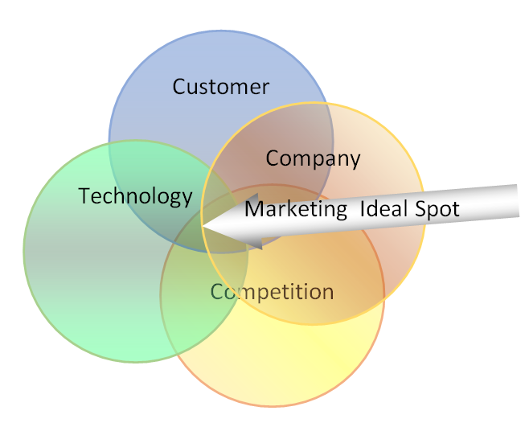

**Market Segmentation**

We have identified the customers for our business:

* Customers whose house hold income is > $1,000 per month.
* Customers are estimated aged between 14 years and above. We use a lower age bottom segmentation than other e-commerce business because nowadays teens are already equipped with internet technology and our online ordering system is very easy to use, similar to e-mail accounts.
* Customers / households with children.
* Consumer who are looking for convenience; that means they do not want to invest time in traveling and dining in the eateries.
* Average commute time to work of customers.
* Customers number of households with internet access and its awareness.
* Customers with credit cards or other online payments methods.
* University, college students.
* Active workers of offices, hospitals, other institutions who prefer food delivered to their premises.
* Last but important customers “Female shoppers”.

So we can justify our market segmentation by

|  |  |
| --- | --- |
| **Segmentation Type** | **Variables** |
| Geographic | Metro and cities |
| Demographic | Aged 14-54 years; Income above $1,000 |
| Behavioral | Awareness & access to Internet; Power of using payment through it. |
| Occasion | Planned for personal as well as public occasions. |
| Benefits | Ease of purchase; power of freeness; Fast delivery service provided |

**Advertisement Strategy**

Several ways which we will conduct to promote and advertise our site:

* Advertising it in the popular sites as Yahoo, Hotmail, MSN etc.
* Registering our site in various search engines like Google, MSN, Bing etc.
* Using broadcasting advertisements i.e. television & radio.
* Using outdoor advertisements i.e. posters, billboards, banners etc.
* Introducing our site through print advertisements: newspapers, magazines, fliers, brochures.
* Incorporating rich media / multimedia advertisements featured in various sites.

**Operations Strategy**

Our operations are carried out according to:

**Business to Customers (B2C)**

As in this category our consumers care how the order is delivered so we have designed our own delivery services. In this category we also offer sellers the option to use our delivery personnel, so we are keeping our eye on statistical analysis of our customer base to figure out what’s going on at any point in time with any particular type of customer.

**Operations Model**

**Effective delivery model**

In this category, we are maintaining our delivery services that are able to handle fulfillment to online customers. Delicious is improving the face of online eatery business, so we also have the delivery team that would manage delivery once the order is ready to be allocated to customers. We do not require the eateries to use our delivery personnel but provide assistance when needed and the sellers can rent our personnel. Waiting by at the sellers’ kitchens, our personnel are alert, accurate, and ready to depart with customers orders.

Our demand chain is as follows according to:

**Fees for delivery**

Delivery fees are determined and charged by the eateries. We also provide a tool to determine the estimated delivery time based on current traffic and distance between the eatery and the customer's location. Our Delicious.com team also gives updates by phone, email, text messages to the customer when the order is ready to be delivered.

**Technology behind Our Website**

In an online business, technology is definitely the most important thing. The whole system is dependent on the technology that we will be using, therefore we should ensure that we take proper decisions on the architecture on which our system will be developed ,the hardware the software that we will using and proper security measures to ensure that our clients can have secure transactions.

**Features**

The following are the technology features of Delicious:

* Our website are easy to use, easy to maintain, easy to learn, easy to navigate. It is also intuitive, consistent, efficient, error-free, and functional.
* Secure payment system for online transactions using all popular credit cards, debit cards, PayPal, gift cards, and other relevant payment options, as available from time to time.
* Fast, robust, scalable
* Supports con-currency of 300 users

**Architecture**

The architecture that we will be using is three-tiered applications of J2EE architecture.

The picture below describes the multi-tiered Java EE applications that has components:

* Client-tier components: run on the client machine.
* Web-tier components: run on the Java EE server.
* Business-tier components: run on the Java EE server.
* Enterprise information system (EIS)-tier software: runs on the EIS server.

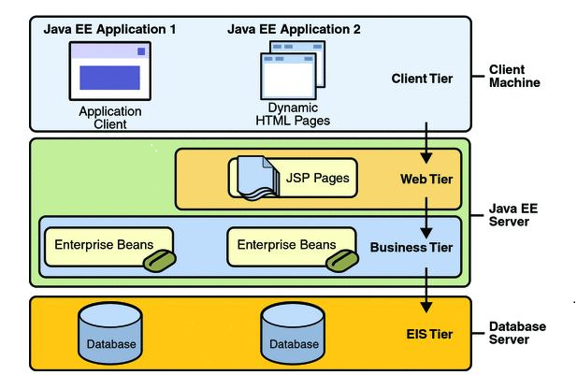

Although a J2EE application may consist of three or four tiers shown in Figure 1-1, it is generally considered to be three-tiered applications, distributed over three locations: client machines, the Java EE server machine, and the database or legacy machines at the back end.

**Operating System**

The OS that will be used is UNIX (HPUX).

**Database**

We will use the racle 9i database.

**Application Server**

The application server will be the Oracle WebLogic Portal, the best portal framework for creating highly interactive applications in a service-oriented architecture (SOA) environment, recognized as the number one application server across traditional and cloud environment. It provides flexibility between on-site and third party clouds, and is optimized for Oracle Exalogic Elastic Cloud. It offers extreme cloud performance, scalability, elasticity, unmatched integration with Oracle's Database 12c including multi-tenant database support, and can increase productivity with mobile application development.

**Web Server**

Apache Tomcat 7 Server: Apache Tomcat is an open source web server and Servlet container which implements the Java Servlet and the Java Server Pages (JSP) specifications from Sun Microsystems, and provides a "pure Java" HTTP web server environment for Java code to run in.

**Web Browsers**

Browsers that will be compatible are Mozilla Firefox, IE7+, Google Chrome, and Netscape.

**Security**

We would take several steps to protect the sellers and their customers when completing e-commerce transactions.

**Login ID & Passwords:**

To identify the person who is accessing the website, users are expected to login using their login IDs (usernames) and passwords which would be saved and encrypted in the database to safeguard the user's privacy.

**Firewall**

A firewall would control the incoming and outgoing network traffic by analyzing the data packets and determining whether they should be allowed through or not, thus it is useful to prevent unauthorized access of the site, safeguard private information, and intercepts all messages entering and leaving the network.

**SSL, S-HTTP:**

Using a cryptographic system to encrypt data with two keys, Secure Socket Layer (SSL) creates a secure connection between a client and a server over which any amount of data

can be sent securely. S-HTTP helps to pass on individual messages securely.

**VeriSign Certification:**

Our system will be VeriSign certified to assure visitors that their personal information will remain private.

**Public Key Infrastructure**

To enable the users exchange data and money through the use of a public and a private cryptographic key pair that is obtained and shared through a trusted authority, making the data is accessed by the authorized and the intended users only.

**Management Structure**

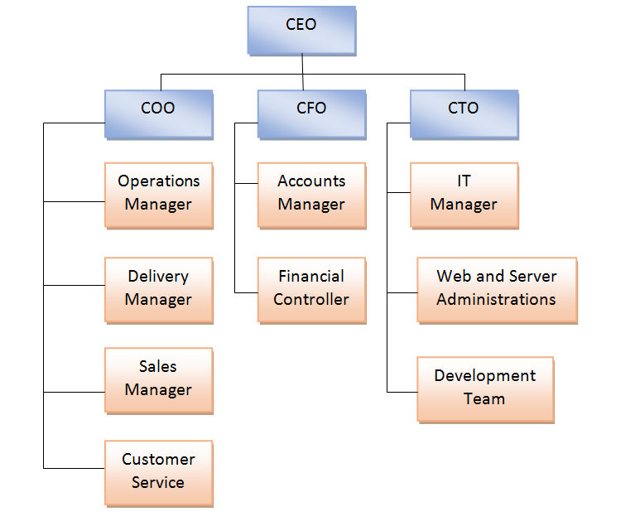

Abbreviations:

CEO = Chief Executive Officer.

COO = Chief Operating Officer.

CFO = Chief Financial Officer.

CTO = Chief Technology Officer.

**Financial Consideration**

In this section, we would lay out financial plans and details, also our fund sourcing and profit estimation.

**Capital Estimation**

Our operation would be started with renting official spaces rather than buying it or building our

own offices. This would help us in terms of flexibility. We plan to have the following:

**1. Fixed Assets**

1. **One Headquarter in New York City** – This would be a strategic location since New York is the most populous and most densely populated city in the United States. It is also having the most high-rise buildings or offices, and the homes to numerous colleges and universities, which would be the direct demographics for our business. Our headquarter would also be used for the top management, monitoring, and business development.

2. **One Research and Development Center, San Francisco** –The city flourishes with technological advancements would nurture e-commerce players and start-up companies with the perfect environment and plenty helps for growing, innovating and putting itself in the head of the game. This R&D main role is to be the development, technological setup, server location, and also maintenance site.

3. **Five Regional Offices** – Spread across 5 cites namely, Los Angeles, Boston, Seattle, Houston, and Chicago. These serve as Business Development Centers and Regional

Offices.

4. **Delivery Centers** – A total of 10 delivery centers spread across the cities. These would function as small offices to manage our local delivery teams. If requested by the eateries, the employees would be dispatched to the eateries and help delivering the orders to locations specified by customers.

**2. Transportation**

We plan to equip each delivery centers with smart cars and motorbikes for delivery purposes.

**3. Human Resource**

We would have a CEO, CFO, CTO, COO, all posted in the headquarter comprising the top management team. Each regional office is equipped with a head manager who would report to the head quarter. Each delivery center is equipped with the delivery manager and a numbers of deliverymen depending on how festive the businesses would be.

**4. Technology Setup**

Main technology setup would be hosted at the San Francisco office. This would include Hardware, Software, PC, Servers, Telephones, Networks, etc.

**5. Costs and Expenses**

This section illustrates the costs, maintenance inventory costs etc.

|  |  |  |  |
| --- | --- | --- | --- |
| Infrastructure | Est. Yearly Cost per Unit | Number | Total |
| Headquarter: NYC | 346932 | 1 | 346932 |
| Regional Offices |  |  |  |
| Los Angeles | 87768 | 1 | 87768 |
| San Francisco | 71622 | 1 | 71622 |
| Boston | 83214 | 1 | 83214 |
| Houston | 66309 | 1 | 66309 |
| Chicago | 66125 | 1 | 66125 |
| Seattle | 67137 | 1 | 67137 |
| Delivery centers | 26000 | 10 | 260000 |
| Total Infrastructure | | | 1049107 |
| Transportation Assets | Est. Price | Number | Total |
| Smart cars | 12000 | 30 | 360000 |
| Motorbikes | 300 | 60 | 18000 |
| Total Transportation Assets | | | 378000 |
| Human Resource | Est. Yearly Salary per Person | Number | Total |
| CEO | 300000 | 1 | 300000 |
| CFO | 150000 | 1 | 150000 |
| CIO | 150000 | 1 | 150000 |
| CMO | 150000 | 1 | 150000 |
| Delivery Managers | 50000 | 6 | 300000 |
| Sales, Operations, Accounts, IT Managers | 70000 | 4 | 280000 |
| IT Techs | 80000 | 10 | 800000 |
| Accountants | 60000 | 6 | 360000 |
| Financial Controller | 60000 | 3 | 180000 |
| Delivery Personnel | 30000 | 30 | 900000 |
| Other employees | 35000 | 20 | 700000 |
| Total Human Resource | | | 4270000 |
| IT Setup |  |  | 1000000 |
| Maintenance |  |  | 200000 |
| Advertising |  |  | 100000 |
| Total Costs | | | 6997107 |

**Fund Distribution**

**Fund Sourcing**

We plan to obtain capital from venture capitalists, individual contributions, and private investors.

* **Individual Contribution – Partnership**
* $ 500,000 per partner
* $ 2,500,000
* **Venture Capitalist’s Contribution**
* $ 2,000,000
* **Private Investors**
* $ 2,500,000

**Break Even Analysis**

We plan to have at least 100 prominent eateries from 7 cities to join for the first month after commencing this business. The commission revenue per month from each eatery is estimated as $3000, securing about $300,000 in a month. The listing and registration fees should give in about $700 per eatery and advertising from other sponsors should provide at least $100,000 per month, totaling in $170,000. Fees of renting our delivery personnel who would regularly work 10 hours in a day and there is about 30 available men, should produce $72,000. Hence, in our first month, we only yield $1,476,000 revenue. Expecting a double growth of revenue per five months, break-even is expected to occur within 21 months of startup.

**Exit Strategy**

We plan to have some back-up strategies that would help to start our business.

1. IPO – Initial Public Offering
2. Exploring support from Silicon Valleys: angel investors and private contributions.
3. Join an existing online retail business in a different vertical i.e. Ebay.com, Amazon.com.
4. Acquisitions with other companies which have similar operations. Eg: GrubHub.

**References**

Electronic Commerce 2012 – Efraim Turban, David King, Jae Lee, Ting-Peng Liang, Deborrah Turban.

http://www.about.com

http://www.bplans.com

http://www.businessweek.com

http://www.b-plan.com

<http://docs.oracle.com/javaee/5/tutorial/doc/bnaay.html>

<http://tomcat.apache.org/>